# Section 18: Twenty-first to Forty-fourth Vassa in Sāvatthī (From Age 55 Onwards)

According to tradition, after spending his twentieth vassa in Rājagaha, the capital of the ancient Magadha Kingdom, the Buddha travelled to Sāvatthī, then the capital of the Kosala Kingdom. He spent the next twenty-four rains retreats in and around Sāvatthī, primarily residing in two renowned monasteries of that time: Jetavana and Pubbārāma (Purvarāma). Of these twenty-four vassas, he spent eighteen in Jetavana and six in Pubbārāma.

### References from Other Sources

Various sources confirm that during these twenty-four rainy seasons, the Buddha resided in Sāvatthī:

* From the twenty-first vassa onwards, he is known to have relied on Sāvatthī as his primary dwelling, residing in the Great Monastery at Jeta’s Grove and the Eastern Monastery. These locations were well-supplied with requisites, supporting the large monastic community. [1]
* The Sage, who delighted in the progress of the world and dwelled in happiness, spent the next twenty-five rains retreats near Sāvatthī, in the serene and excellent Jeta’s Grove and the beautifully adorned Eastern Monastery, which was said to resemble a celestial abode. .[2]

### Journey from Rājagaha to Sāvatthī

Based on modern geographical estimates (see: map 2), the Blessed One, accompanied by a retinue of five hundred bhikkhus, [3] may have walked approximately 597 km (about 48 yojanas) from Rājagaha to Sāvatthī.

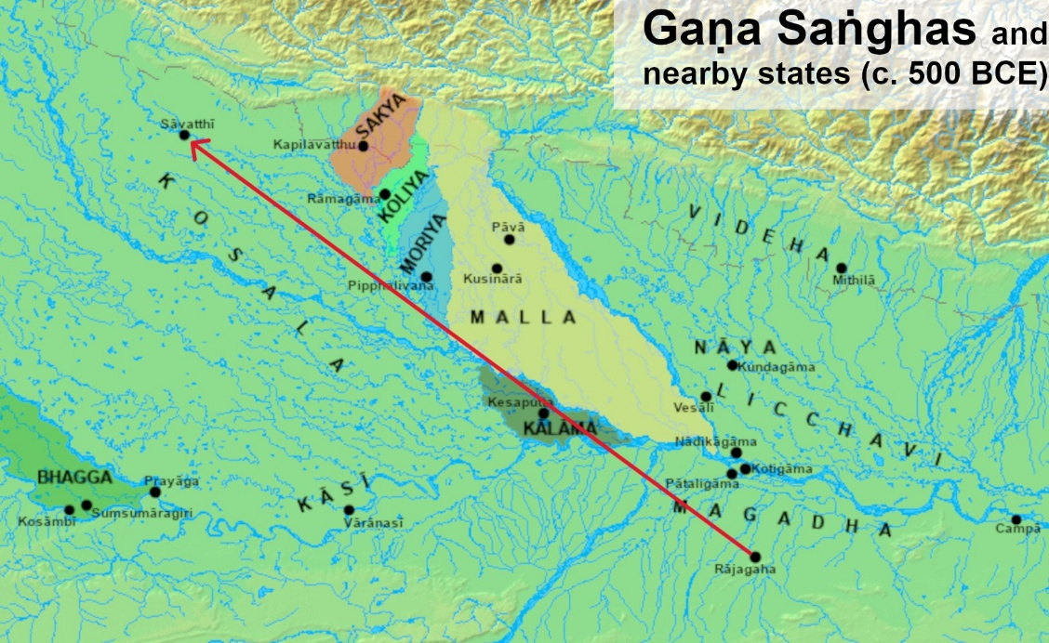

**Map 1: Ancient India map during the time of the Buddha showing the location of ancient cities Rājagaha in Magadha Kingdom and Sāvatti in Kosala Kingdom – The Route taken by the Buddha [4]**

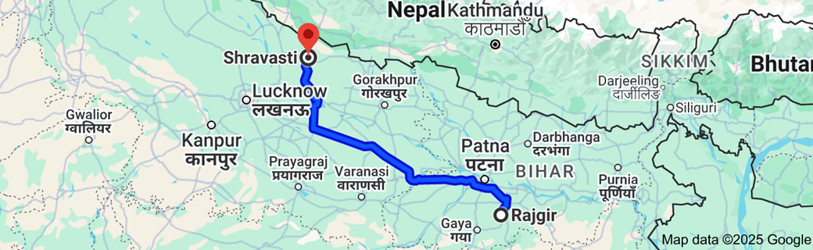

**Map 2: Modern map showing the location of Rajgir in Bihar and Shravasti in Uttar Pradesh Distance between the two cities is 596.7 km** [5]

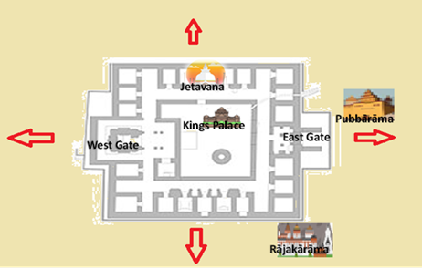

**Floor Plan of City of Sāvatti during the time of the Buddha showing the three main monasteries [6]**

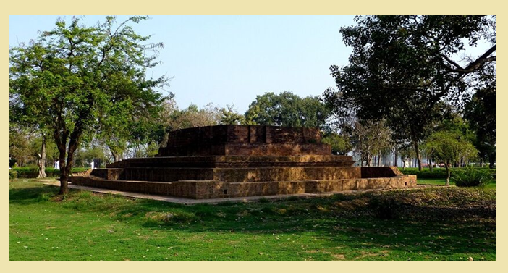

**Ruins of Jetavana Moanstery in Sāvatti [7]**

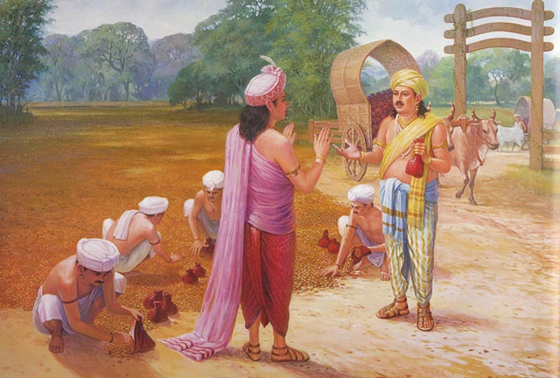

**Spreading gold coins on the park of Prince Jeta by Anāthapiṇḍika to complete his deal and recognizing the amazing event, Prince Jeta offering a piece of land as his contribution [8]**

## Jetavana Monastery – Anāthapiṇḍika-ārāma in Sāvatthī

As mentioned earlier (see Section 14-3), the wealthy merchant Sudatta—widely known as Anāthapiṇḍika—first encountered the Blessed One in Rājagaha. Profoundly moved by the Buddha’s teachings, he became an ardent follower and extended an invitation for the Buddha and his Saṅgha to visit his city, Sāvatthī. With unwavering devotion, he then established Jetavana Monastery, making a generous offering of this sacred space to the Buddha and the monastic community.

According to the scriptures and tradition, Jetavana became one of the most significant places in the Buddha’s ministry. Between the rains retreats, the Blessed One frequently returned to Jetavana, staying there for extended periods and delivering numerous discourses. These teachings transformed countless lives, leading many lay disciples to take refuge in the Buddha, Dhamma, and Saṅgha.

The fourteenth vassa at Jetavana was especially significant, as the Buddha personally guided his son, Venerable Rāhula, in deepening his spiritual practice (see Section 16-1). Tradition and scriptural records further affirm that a vast number of discourses in the Tipiṭaka were delivered during the Buddha’s long residence in Sāvatthī, particularly at Jetavana. Many of these teachings became foundational to the Dhamma, shaping the spiritual path for generations to come.

In the following sections, we will explore some of these profound discourses, illuminating the wisdom the Blessed One imparted during his time at Jetavana.

## Pubbārāma Monastery (Pubbārāma – Eastern Park Monastery, Migāramātupāsāda)

Among the many devoted lay followers of the Blessed One, Visākhā Migāramātā shone as an exceptional disciple, renowned for her unwavering faith and generosity. The Buddha himself declared her the foremost among female donors, recognizing her immense contributions to the Saṅgha and her compassionate efforts in guiding others to the Dhamma. [9]

Visākhā was born into a family of great wealth and virtue. Her father, Dhanañjaya, was a prominent merchant, and her mother, Sumanadevī, hailed from the prosperous city of Bhaddiya in the Anga province. Her grandfather, Mendaka, was regarded as the wealthiest man of his time. Despite being surrounded by luxury, young Visākhā possessed rare wisdom and spiritual insight. [10]

At the age of seven, during one of the Buddha’s visits to her region, she had the great fortune of encountering the Blessed One. Upon listening to his sublime teaching, she attained **stream-entry (sotāpatti),** securing her path toward liberation.

In time, King Pasenadi invited Visākhā’s family to settle in the Kosala kingdom. They moved from Bhaddiya to Sāketa, where Visākhā later married Puṇṇavaḍḍhana, the son of the wealthy merchant Migāra of Sāvatthī. Her new family, however, were followers of Nigaṇṭha Nātaputta (leader of the Jain ascetics). Through her wisdom and skilful means, Visākhā gradually won their hearts, guiding them to the Buddha’s teachings. Eventually, her father-in-law, Migāra, embraced the Dhamma and became a devoted follower. In honour of this transformation, Visākhā was thereafter affectionately called **Migāramātā,** or "Mother of Migāra."

### The Building of Pubbārāma Monastery

The story of how Visākhā built Pubbārāma Monastery is one of deep devotion and noble intention.

One day, while visiting Jetavana Monastery, Visākhā lost some of her valuable jewelry. The monks, upon discovering it, sought the Buddha’s guidance and safely stored it away. [11]

When Visākhā realized her, lost ornaments were in the monastery, she decided not to reclaim them for personal use. Instead, she resolved to sell the jewellery and dedicate the proceeds to constructing a monastery where the Buddha and his Saṅgha could reside in Sāvatthī.

With the Buddha’s blessing, Venerable Mahā Moggallāna oversaw the construction of the monastery. Within just nine months, a magnificent two-story monastery, fully equipped with all necessary facilities, was completed. Since it was built near the eastern gate of Sāvatthī, it became known as Pubbārāma – the Eastern Monastery**.** However, in both scripture and tradition, it was more commonly referred to as Migāramātupāsāda – the Palace of Migāramātā**,** in honour of Visākhā’s profound generosity.

Pubbārāma was not merely a place of shelter but a sacred space where countless beings, from monastics to lay devotees, found inspiration, guidance, and refuge in the Buddha’s teachings. It stood as a testament to Visākhā’s unwavering faith, her boundless generosity, and her lifelong dedication to supporting the Saṅgha and spreading the light of the Dhamma. [12]

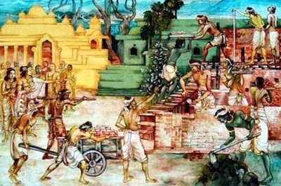

**Visākhā** **supervising the building of her monastery** [13]

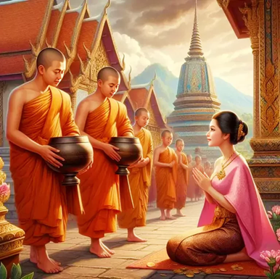

**Visākhā offering alms to the Sangha at the beautiful Pubbārāma monastery [14]**

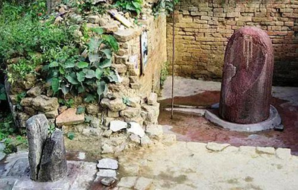

**Ruins of Pubbārāma monastery in Sāvatthī with a pillar built by King Asoka [15]**

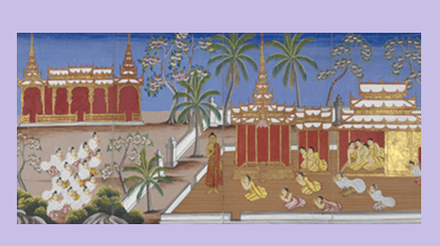

**Rājākārāma Nuns Monastery in Sāvatthī- bhikkhunis and lay women paying homage to the Buddha[16]**

## The Monastery Built by King Pasenadi Kosala for the welfare and protection of Bhikkhuni Sangha

According to tradition the King Pasenadi of Kosal built a nunnery —monastery called Rājākārāma for bhikkhuni sangha near the south east of the city of Sāvatthi. [17]It also says that this good deed was done by the suggestion of the Buddha. The background story goes like this: While the Buddha was residing in Sāvatthi, Venerable Uppalavaṇṇā was living in Andhavana, a forest grove south of the city of Sāvatthi, there living in solitude she was attacked by a young man who was a cousin of her who wanted to marry her during her lay life, but seen the calamity of household life she refused many such offers and became a disciple of the Buddha. The Buddha with his deep compassion prohibited bhikkhunis to live alone in forest groves without protection.[18] Hence, the King built a beautiful monastery for the nuns.

In SN5: Bhikkhunisamutta refers to this abode as ‘Bhikkhuni Quatres’, according to the discourses in that samyutta many bhikkhunis were residing there when the Buddha was spending his long stay in Sāvatthi , among them were bhikkhunis: Uppalavaṇṇā Āḷavikā, Somā, Kisāgotamī, Vijayā, Cālā, Upacālā, Sīsupacālā ,Selā and Vajirā. [19]

According to tradition this was the second monastery dedicated to the Nuns. First was in Vesāli where Prajāpati Gotami and her five hundred companions lived after their ordination. This source gives a brief account of the first monastery for nuns and below we can see the pictures of the ruins of that monastery.[20]

Hence, we can see how the King Pasenadi Kosal and his Queen Mallika both ardent followers of the Buddha supported the Buddha’s dispensation by not only looking after the bhikkhu sangha but the bhikkhuni sangha too!

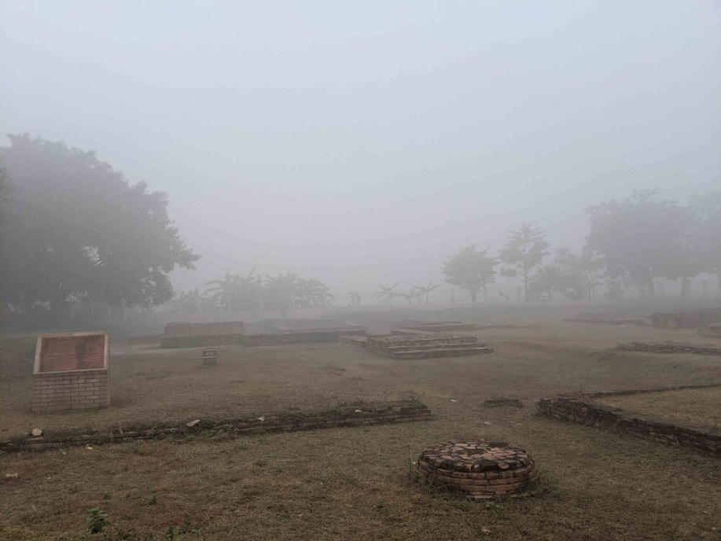

**The Vesali Monastery was the first dedicated to the bhikkhunis, and it is where Mahapajapati Gotami and other women were ordained. [21]**

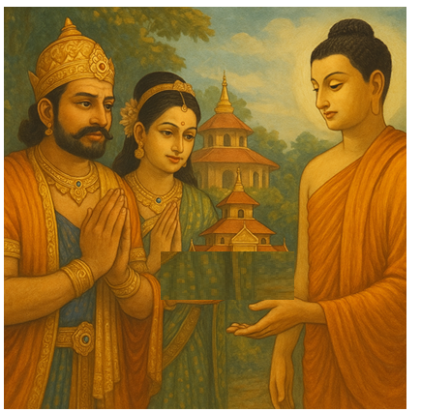

**King Pasenadi and Queen Mallika offering the Buddha the first monastery dedicated to bhikkhunis [22]**

## Dhamma Advice to the Sangha

According to the scriptures, during his long stay in Sāvatthī, the Buddha delivered numerous profound discourses for the welfare of the Sangha, guiding them towards liberation. Each of these teachings played a vital role in the spiritual progress of the disciples and cannot be ranked or compared—just as gold mined from the earth is precious in every form, each word of the Blessed One is invaluable. However, to illuminate the essence of his wisdom, we have selected a few key teachings that offer deep insight into the path of purification**.**

### How to Destroy the Taints

In the *Sabbāsava Sutta* (MN: 2), the Buddha expounds on the nature of taints (*āsavas*)—the deep-rooted defilements that bind beings to the cycle of birth and death. He teaches seven methods by which these taints can be restrained and abandoned:

1. Abandoning by Seeing – Through wise attention (*yoniso manasikāra*), one should avoid unskilful perceptions that give rise to sensual desire, ill will, restlessness, laziness, and doubt. Instead, by contemplating the Four Noble Truths with clarity, one can uproot the fetters of personality view, doubt, and attachment to rites and rituals.
2. Abandoning by Restraining – The wise disciple practices mindfulness and restraint over the six sense faculties (eye, ear, nose, tongue, body, and mind). By guarding the senses, one prevents the arising of sensual fever, ill will, and other unwholesome states.
3. Abandoning by Using – Reflection on the proper use of requisites (robes, alms food, dwelling, and medicine) is crucial. These should be used not for indulgence, adornment, or pleasure but solely to maintain the body for the sake of spiritual cultivation.
4. Abandoning by Enduring – One must develop patience and endurance in the face of external hardships, such as heat and cold, hunger and thirst, insect bites, harsh speech from others, and physical discomfort. By accepting these challenges with wisdom, the mind remains undisturbed.
5. Abandoning by Avoiding – With careful discernment, one avoids situations that could hinder spiritual growth. This includes physical dangers (such as wild animals or perilous locations like cliffs and swamps), harmful associations (such as unwholesome companions who encourage misconduct), and places of immorality (such as gambling houses, bars, and other sites of indulgence in sensual pleasures).
6. Abandoning by Removing – When unwholesome thoughts of sensuality, ill will, or delusion arise, one must apply mindfulness and right effort to swiftly remove them, replacing them with wholesome mental states that support the path.

These seven methods serve as essential tools for the Sangha in their pursuit of liberation, helping them sever the chains of defilement and move towards the ultimate goal—Nibbāna.

### Overcoming Anger and Ill Will

On one occasion, while residing in Sāvatthī, the Buddha addressed the monks, saying:

*“Bhikkhus, there are five kinds of speech that others may use when they speak to you. Their words may be timely or untimely, true or false, gentle or harsh, beneficial or harmful, spoken with a mind of loving-kindness or with inner hatred. Regardless of how others address you—whether their words are kind or cruel, truthful or deceptive, spoken with goodwill or malice—your response must be rooted in wisdom and restraint”. [23]*

Here, bhikkhus, you should train yourselves in this way:

*‘Our minds shall remain unshaken, and we shall utter no evil words. We shall abide with a heart full of compassion, wishing only for the welfare of others. With a mind free from hatred, we shall pervade even those who speak harshly with boundless loving-kindness. Beginning with them, we shall extend this goodwill to the entire world——vast, exalted, immeasurable, and free from hostility and ill will.’*

Bhikkhus, even if bandits were to seize you and savagely cut you limb by limb with a two-handled saw, if you were to give rise to even a moment of hatred towards them, you would not be following my teaching. Instead, you should train in this way:

*‘Even in the face of unbearable cruelty, our minds shall remain unshaken, and we shall utter no harsh words. We shall abide in unwavering compassion, free from resentment. We shall pervade even our tormentors with a heart of loving-kindness, without ill will.’*

Bhikkhus, if you hold firmly to this teaching—this simile of the saw—do you see any form of speech, whether trivial or severe, that you could not endure?”

The monks replied, “No, venerable sir.”

“Therefore, bhikkhus, keep this teaching close to your hearts at all times. Doing so will bring you welfare and happiness for a long time.”

This profound teaching of the Blessed One conveys the profound strength of patience and loving-kindness in the face of all provocations. It reminds us that true spiritual mastery lies not in seeking favourable conditions, but in maintaining unwavering compassion even under the harshest circumstances.

### The Danger of Misapprehending the Dhamma

To warn against the dangers of grasping the Dhamma with the wrong intention, the Buddha gave this profound teaching in the *Alagaddūpama Sutta* (MN:22).

“Bhikkhus, some misguided individuals learn the Dhamma, but instead of reflecting on its true meaning with wisdom, they use it merely to criticize others and win debates. Failing to apply it for inner transformation, they derive no real benefit. Misinterpreted and misused, the Dhamma becomes a cause of their own harm and suffering—just as a man who carelessly grasps a snake by its tail or coils risks being bitten, leading to great pain or even death.”

On the other hand, those who learn the Dhamma with right intention examine its meaning with wisdom, develop deep understanding, and apply it to their lives. They do not seek to argue but to cultivate inner peace and liberation. Such individuals, having grasped the Dhamma correctly, experience true welfare and happiness—just as a skilled person, using a cleft stick, grasps a snake properly by the neck and avoids harm.

Thus, the Buddha advised:  
**“Bhikkhus, if you understand my teachings, remember them well. If you do not, seek guidance from me or from wise bhikkhus.”**

This teaching reminds us that the Dhamma is not meant for intellectual pride or debate but for liberation. When grasped correctly—with wisdom, humility, and sincerity—it leads to the highest happiness.

### Advice to Venerable Bhaddāli

Once, while residing at Jetavana Monastery, the Buddha gave a firm yet compassionate teaching to Venerable Bhaddāli to help him overcome stubbornness and progress on the path

The Buddha instructed the monks:  
*"Bhikkhus, I eat only one meal a day. By doing so, I remain free from illness, experience lightness, strength, and a comfortable abiding. You too should follow this practice to gain the same benefits."[24]*

However, Venerable Bhaddāli resisted, fearing discomfort. When the Buddha formally introduced this training rule, Bhaddāli refused to comply and, feeling ashamed, avoided the Buddha for the entire three-month Rains Retreat.

Out of concern for his well-being, some monks urged him:  
*"Friend Bhaddāli, the Buddha’s robe is being prepared, and when it is completed, he will set out on his journey. Take this opportunity to approach him before it becomes more difficult for you."*

Realizing his mistake, Bhaddāli finally sought the Buddha’s forgiveness:  
*"Venerable Sir, please forgive my transgression, seen as such, for the sake of future restraint."*

The Buddha, ever compassionate, pardoned him and gave this profound teaching:

#### The Simile of the Thoroughbred Colt

*“ Bhaddāli, suppose a skilled horse trainer acquires a fine thoroughbred colt. First, he trains the colt to wear a bit. Since this is unfamiliar, the colt resists—writhing and struggling. But with patience, repetition, and gradual practice, it learns to accept the bit with ease.*

*Next, the trainer introduces the harness. Again, the colt resists at first but, through steady training, becomes accustomed to it. The trainer then teaches it to step in rhythm, run in circles, prance, gallop, and charge—refining its skills until it develops the noble qualities of a king’s horse: speed, agility, and gentleness. Finally, when the colt masters all these actions, it is rewarded with care and grooming. When a thoroughbred colt possesses these ten qualities, it is fit to serve a king and is regarded as one of the king’s prized assets."*

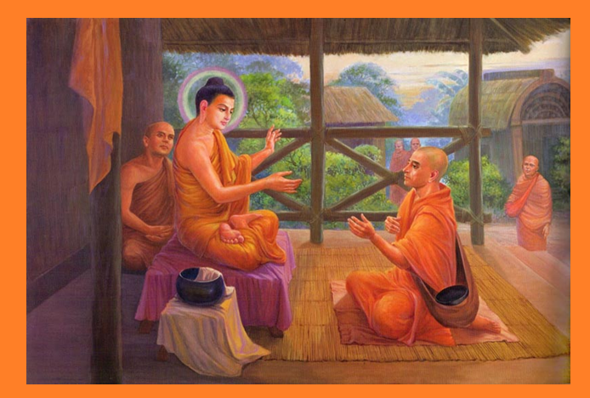

**The Buddha, ever compassionate, pardoned Venerable Bhaddāli [25]**

Then the Blessed One further said:

*"Bhaddāli****, a bhikkhu with ten qualities*** *is truly worthy of offerings, hospitality, reverence, and is an unsurpassed field of merit for the world. What are these ten? A bhikkhu must possess the right view, right intention, right speech, right action, right livelihood, right effort, right mindfulness, right concentration, right knowledge, and right deliverance—each perfected beyond mere training. When a bhikkhu attains these, he becomes a beacon of virtue and wisdom."*

Hearing these words, Venerable Bhaddāli was deeply satisfied and delighted in the Buddha’s teaching.

This story reminds us that even when discipline feels challenging, true growth comes from humility, self-reflection, and aligning with the Dhamma.

### Advice to Venerable Puṇṇa

While residing at Jetavana Monastery, the Blessed One was approached by Venerable Puṇṇa, who paid homage and respectfully requested a brief teaching that would enable him to dwell in solitude and practice diligently. **[26]**

With boundless compassion, the Buddha imparted a concise yet profound discourse. He explained how suffering arises due to craving and how it ceases with the abandonment of craving. Elaborating further, he taught:

*"When delight arises in relation to the eye and forms—or to any of the six sense faculties and their objects—the suffering of the five aggregates follows. Thus, the arising of suffering and its origin can be understood through the six senses. But if a bhikkhu does not delight in, welcome, or cling to these external objects—whether sights, sounds, smells, tastes, touches, or thoughts—then delight ceases in him. And with the cessation of delight, Puṇṇa, there is the cessation of suffering."*

After delivering this discourse, the Buddha inquired about where Venerable Puṇṇa intended to practice. Upon hearing that he planned to go to Sunāparanta, the Buddha cautioned him:

*"Puṇṇa, the people of Sunāparanta are fierce and rough. If they abuse and threaten you, how will you respond?"*

Venerable Puṇṇa replied with remarkable patience and wisdom, saying that if they merely abused him, he would consider them kind for not striking him. The Buddha continued to challenge him:

"But what if they strike you with their fists?"

"Then I shall think: 'How fortunate that they did not strike me with a clod of earth.'"

"And if they do strike you with a clod?"

"Then I shall think: 'How kind they are for not striking me with a stick.'"

The Buddha pressed further, asking what he would think if they struck him with a stick, a knife, or even took his life. Each time, Puṇṇa responded with unwavering equanimity, seeing even death as an opportunity for final liberation. Deeply pleased, the Buddha affirmed:

"Good, good, Puṇṇa! With such self-restraint and serenity, you will be able to dwell in Sunāparanta."

True to his resolve, Venerable Puṇṇa journeyed to Sunāparanta and lived according to the teachings. Scriptures record that through his efforts, five hundred laymen and five hundred laywomen took refuge in the Dhamma. In time, he passed away.

When news of his passing reached Jetavana, some bhikkhus approached the Buddha, asking about his fate. The Blessed One replied:

*“Bhikkhus, the clansman Puṇṇa was wise. He practiced in accordance with the Dhamma and never troubled me with questions about its meaning. He has attained final Nibbāna.”*

Thus, Venerable Puṇṇa’s unwavering resolve and steadfast practice serve as a shining example of true renunciation and fearlessness in the path to liberation.

### Anāthapiṇḍika’s Progress on the Path and His Final Moment

Anāthapiṇḍika, the foremost male lay devotee of the Buddha, was renowned for his boundless generosity and deep devotion. Though immensely wealthy, he remained humble and used his fortune to support the Sangha, providing the four requisites with a heart full of faith. His selfless giving was not merely an act of charity but a path to spiritual progress, leading him closer to liberation.

In his final days, as he lay gravely ill, Venerable Sāriputta visited him and offered profound guidance, recorded in MN: 143: Anāthapiṇḍikovāda Sutta:

*"Householder, you should train thus: ‘I will not cling to what is seen, heard, sensed, cognized, encountered, sought after, and examined by the mind, and my consciousness will not be dependent on that.’ Thus, you should train."*

These words penetrated Anāthapiṇḍika’s heart, and with unwavering wisdom, he let go of all attachment. In that very moment, he attained the fruit of non-returner (*anāgāmī*), transcending worldly rebirth. Shortly thereafter, he passed away and was reborn in the celestial Tusita realm.

Now appearing as a radiant young deva, he descended to Jetavana Monastery, illuminating the entire grove. With deep reverence, he paid homage to the Blessed One and expressed his realization in inspired verses:

*"Blessed indeed is this Jeta’s Grove,  
Dwelling place of the noble Sangha,  
Wherein abides the King of Dhamma,  
The source of all my happiness.*

*"Not by birth or wealth alone  
Are beings purified,  
But through wisdom, virtue, and truth—  
These are the paths to liberation."*

*"Thus, the wise who seek true welfare  
Should investigate the Dhamma well,  
Walk the path of purification,  
And free themselves from suffering."*

Thus, Anāthapiṇḍika’s journey stands as a luminous example of generosity, devotion, and wisdom. From a life of selfless service to final liberation, he exemplified the highest virtues of a lay disciple, inspiring countless generations to follow the path of Dhamma.

### The Story of Venerable Puṇṇikā, Adopted Daughter of Anāthapiṇḍika

The *Therīgāthā* recounts the inspiring story of Puṇṇikā, who was born into servitude in the household of Anāthapiṇḍika. [27] In past lives, she had been well-versed in the Dhamma under previous Buddhas, but due to her pride, she was reborn as a slave. Yet, her past merits bore fruit—living in the home of the Buddha’s foremost lay disciple, she frequently accompanied her master and mistress to Jetavana Monastery, where she offered alms and listened to the Blessed One’s teachings.

One day, upon hearing a profound discourse, her wisdom awakened, her past unwholesome kamma was subdued, and she attained *sotāpatti* (stream-entry). Witnessing her spiritual progress, the compassionate Anāthapiṇḍika did not see her as a mere servant but as a noble being walking the path of liberation. In an extraordinary act of generosity, he freed her from servitude and adopted her as his daughter. He humbly recognized her wisdom, bowing not to status but to the Dhamma itself. Seeing her deep aspiration to renounce worldly life, he escorted her to the Bhikkhunī Sangha, where she became a nun and eventually attained arahantship.

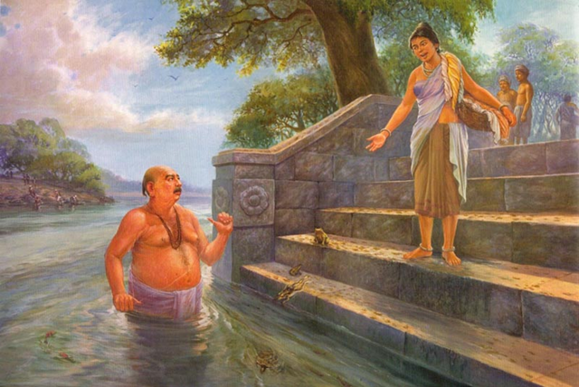

**Puṇṇikā challenging the silly rituals of Brahmin Uddaka Sodhaka [28]**

#### Puṇṇikā’s Wisdom: The Dialogue with the Brahmin

Even before her ordination, Puṇṇikā’s wisdom shone brightly. One early morning, while fetching water from the river, she encountered a Brahmin named Uddaka Sodhaka, who was shivering as he bathed. She inquired about his daily ritual, and he explained that he sought purification from past misdeeds. With keen insight, Puṇṇikā challenged his belief:

**“If water could cleanse bad deeds, then the fish, turtles, and crocodiles should be the purest beings of all. If rivers could wash away wickedness, would they not also wash away virtue? True purification comes not from bathing but from abandoning unwholesome actions.”**

Hearing her wisdom, the Brahmin's delusion shattered. Guided by Puṇṇikā, he sought refuge in the Buddha, ordained as a bhikkhu, and eventually attained arahantship.

Anāthapiṇḍika, ever rejoicing in the spreading of the Dhamma, was deeply pleased by this incident. Recognizing Puṇṇikā’s extraordinary wisdom, he supported her path to ordination, leading to her final liberation.

#### The Legacy of Generosity and Wisdom

Puṇṇikā’s story beautifully illustrates two great virtues—Anāthapiṇḍika’s boundless generosity and reverence for wisdom, and Puṇṇikā’s fearless insight that shattered ignorance. Their lives remind us that true nobility is not found in wealth or status but in selflessness and wisdom. Through her wisdom, Puṇṇikā transformed not only her own destiny but also the lives of those who encountered her, guiding them toward the path of awakening.

## The Spiritual Path of Visākhā: Foremost Laywoman in the Buddha’s Dispensation

The scriptures recount numerous teachings imparted to Visākhā—Migāramātā—by the Blessed One during his long residence at Pubbārāma Monastery in Sāvatthī. These discourses covered a vast range of profound subjects that enriched her wisdom and strengthened her resolve on the spiritual path.

### The Bonds of Saṃsāra: Hard to Escape

On one occasion, Visākhā found herself entangled in a frustrating matter while dealing with King Pasenadi of Kosala. The outcome did not align with her expectations, leaving her troubled and unsettled. Seeking solace, she turned to the one who dispelled all suffering—the Buddha. With unwavering faith, she entered the monastery, paid homage, and sat before him.

Seeing her distressed state, the Blessed One gently inquired:

*“Well now, Visākhā, where have you come from in the middle of the day?”* (Ud 2.9)

Grateful for the opportunity to unburden herself before the Compassionate Teacher, Visākhā replied:

*“Here, Venerable Sir, I am bound up in an affair with King Pasenadi of Kosala,  
but the King does not conclude the affair according to my desire.”*

With profound insight into the nature of worldly entanglements, the Blessed One expounded a brief yet penetrating discourse. He explained how the bonds of saṃsāra—whether arising from one’s own actions or from others—inevitably lead to pain and distress. Why? Because one cannot expect others to yield to one’s will, nor can one impose one’s desires upon the world.

Then, the Buddha uttered this illuminating verse, imbued with timeless wisdom:

**“Painful is all subjection,  
Blissful is complete control.  
People are troubled by common concerns,  
Hard to escape are the bonds.”**

*(Sabbaṃ paramasaṃ dukkhaṃ, sabbaṃ issariyaṃ sukhaṃ;  
Sādhāraṇe vihaññanti, yogā hi duratikkamā.)*

These profound words struck deep within Visākhā’s heart. With wisdom awakened, she realized the futility of clinging to worldly matters and the necessity of inner mastery. Her mind, once troubled, became pacified—another step forward on her noble path to liberation.

## The Fleeting Joy and Lasting Sorrow of Worldly Attachments

Once, while the Blessed One was residing at the Eastern Monastery in Migāramātā’s Mansion near Sāvatthī, Visākhā arrived before him, her clothes and hair still wet with grief. Her beloved granddaughter had passed away, and her heart was heavy with sorrow.

The Buddha, seeing her distress, gently inquired:  
*“Visākhā, where have you come from, with wet clothes and hair, in the middle of the day?”*

She replied:  
*“Venerable Sir, my dear granddaughter has died.”*

With boundless compassion, the Buddha asked:  
**“***Visākhā, would you like as many children and grandchildren as there are people in Sāvatthī?”*

Delighted, she answered:  
**“***Yes, Venerable Sir, I would love that.”*

The Buddha then posed a profound question:  
*“How many people die each day in Sāvatthī?”*

She reflected and responded:  
*“Perhaps ten or eight, Venerable Sir.”*

The Buddha then revealed the deeper truth:  
*“If you had as many children as there are people in Sāvatthī, would you ever be without grief?”*

In that moment, insight dawned upon Visākhā. She realized the weight of worldly attachments and exclaimed:  
**“***Enough, Venerable Sir! I see now.”*

Then, the Blessed One spoke these profound words:

**“For those who love a hundred, there is a hundredfold suffering,  
For those who love ninety, there is ninetyfold suffering.  
The more attachments one has, the greater the sorrow;  
The less one clings, the lighter the heart.”**

And he uttered this timeless verse:

**“All grief, lamentation, and suffering arise from attachment,  
Where there is no attachment, sorrow does not take root.  
Thus, those who seek peace, free from dust and sorrow,  
Should cultivate a heart unattached to the world.”**

Already a stream-enterer, Visākhā saw with clarity how deep attachments bring immense suffering. Strengthened in wisdom, she resolved to loosen the bonds of craving and walk the path of true liberation.

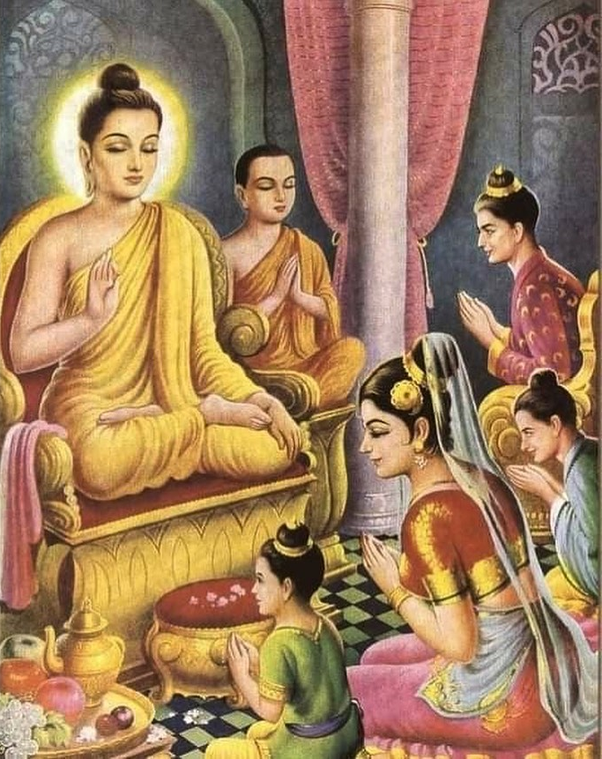

**Visākhā and family paying homage to the Buddha [29]**

### Visākhā: A Life of Virtue, Devotion, and Lasting Merit

Visākhā, the foremost laywoman disciple of the Buddha, lived a life adorned with virtue, wisdom, and boundless generosity. Though she was blessed with immense wealth, she remained humble, kind, and steadfast in her dedication to the Buddha and the Saṅgha. Her unwavering faith and countless meritorious deeds—providing alms, building monasteries, and guiding others on the path of Dhamma—were not only a source of joy in this life but also secured her a blissful rebirth beyond this world.

According to tradition, after passing away, Visākhā was reborn among the **Nimmānaratī Devas**, in the celestial realm of those who delight in creation, as the consort of the deva king Sunimmita. This was the natural fruition of a life spent in selfless service, moral purity, and devotion to the highest truth. Having walked the noble path with diligence, she left behind an inspiring legacy—a testament to the profound happiness that arises from a life well-lived in the Dhamma.[30]

Like Visākhā, may we too cultivate generosity, wisdom, and unwavering faith in the path of liberation. Whether in great ways or small, may we embody even a fraction of her noble qualities, striving to uplift ourselves and others with kindness, humility, and dedication to the Buddha’s teachings. In doing so, we follow in the footsteps of this great lay disciple, securing both present peace and a future of boundless joy!

## Advice to King Pasenadi Kosala and Queen Mallika

King Pasenadi of Kosala became a devoted follower of the Buddha early in the Blessed One’s ministry and remained a steadfast supporter. His chief queen, Mallika, wise and deeply committed to the Dhamma, often guided the king toward a clearer understanding of the truth. The *Kosala Saṁyutta* (SN5) contains numerous suttas recounting their encounters with the Buddha and their progress on the spiritual path. Here, we highlight a key teaching.

### The Power of Diligence

Once, while seated before the Blessed One in Sāvatthī, King Pasenadi asked:

*“Venerable sir, is there one thing that secures both worldly well-being and spiritual fulfillment?”*[31]

The Buddha replied:

*“Indeed, great king, there is one thing that ensures both prosperity in this life and happiness beyond.”*

*“What is that, venerable sir?”*

“Diligence, great king. Just as all footprints fit within the footprint of an elephant—declared supreme for its size—so too, diligence is the foundation of all success, both in this world and in the next.”

### The Blessing of Impartiality

Throughout the scriptures, the Buddha exemplifies impartiality, showing boundless compassion for all—rich or poor, man or woman, high-born or low-born. True wisdom transcends social divisions, recognizing the potential for goodness in every being. In the following exchange, the Buddha offers King Pasenadi a profound lesson on impartiality.

#### A Daughter’s Worth

While seated before the Blessed One in Sāvatthī, King Pasenadi received whispered news:

*“Sire, Queen Mallikā has given birth to a daughter.”*[32]

Displeased, the king’s expression darkened. Perceiving his thoughts, the Buddha spoke these verses:

“O ruler of men, a woman may prove greater than a man.  
She may be wise and virtuous,  
A devoted wife who honours her family.

“The son she bears may rise as a hero,  
O lord of the land.  
From such a noble mother,  
A ruler of the realm may be born.”

Thus, the Buddha gently dispelled the king’s bias, revealing that virtue and greatness are not bound by gender but by the depth of one’s character.

**Who is dearer than oneself?**

On one occasion King Pasenadi asked Queen Mallika

“Is there, Mallikā, anyone dearer to you than yourself?”

There is no one, great king, dearer to me than myself. But is there anyone, great king, more dear

to you than yourself?”

The King said:

“For me too, Mallikā, there is no one dearer than myself.”

Mallikā had been a poor flower girl whom King Pasenadi met by chance after a military defeat. He fell in love with her, married her, and appointed her his chief queen. The king had asked her this question expecting her to say, “You are dearer to me than myself,” and then to ask him the same question, to which he would have given the same reply, so that they would have strengthened their mutual love. But Mallikā, being wise and learned, answered with complete honesty and the king too had to reply in the same way.

Later the King approached the Buddha and related what happened, the Blessed One said thus:

Having traversed all quarters with the mind,

One finds none anywhere dearer than oneself.

Likewise, each person holds himself most dear;

Hence one who loves himself should not harm others.”(SN3: 8)

### Who is Dearer Than Oneself?

One day, King Pasenadi turned to his beloved Queen Mallikā and asked:

*“Mallikā, is there anyone dearer to you than yourself?”*

Without hesitation, she replied:

*“No, great king, there is no one dearer to me than myself. But what about you? Is there anyone dearer to you than yourself?”*

The king, expecting a different answer, was taken aback but had to admit:

*“For me too, Mallikā, there is no one dearer than myself.”*

Queen Mallikā had once been a humble flower girl whom the king met after a bitter military defeat. Enchanted by her wisdom and grace, he married her and made her his chief queen. On this occasion, he had hoped for a romantic affirmation of their love, but Mallikā, ever wise and truthful, spoke with complete honesty—prompting the king to do the same.

Later, King Pasenadi recounted this exchange to the Blessed One. The Buddha, revealing a profound truth, declared:

“Having searched in all directions,  
One finds none dearer than oneself.  
Just as each person holds themselves most dear,  
So too, one who cherishes themselves should not harm others.” (SN 3:8)

Thus, the Buddha transformed personal love into a universal teaching: true self-care is inseparable from compassion for all beings.

## Sorrow Arises from Those Who Are Dear

While staying in Jetavana Monastery, the Buddha was approached by a grieving householder who had lost his only son. Overcome with sorrow, he lamented:

*“Since my son’s death, I have no desire to work or eat. I go to the charnel ground crying, ‘My only son, where are you?’”[33]*

Seeing his distress, the Buddha gently said:

*“So it is, householder, sorrow, lamentation, pain, grief, and despair arise from those who are dear.”*

The man, expecting comfort rather than wisdom, was displeased and left. When others heard the Buddha’s words, they doubted: **“Surely, joy comes from those we love, not sorrow!”** Even King Pasenadi, who had not yet established deep faith in the Buddha, questioned the statement when he heard it. But his wise queen, Mallikā, unwavering in her trust, replied simply:

*“If the Blessed One has said it, then it is so.”*

The king, irritated by her unwavering faith, dismissed her. However, Queen Mallikā sought to reveal the truth of the Buddha’s words. She sent a messenger to confirm the teaching, and the

Buddha affirmed it, illustrating his point with a tragic story:

A woman, forced by her relatives to leave her husband for another, pleaded with her beloved:  
*‘They are separating us against my will!’*

In anguish, her husband, consumed by attachment, committed a terrible act—ending both their lives in the belief that they would reunite in the afterlife.

The Buddha concluded:

“See how sorrow, lamentation, pain, grief, and despair arise from those who are dear?”

When Queen Mallikā relayed this wisdom to King Pasenadi, she asked:

*“Sire, is Princess Vajīrī dear to you?”*

*“Yes, Mallikā, she is very dear to me.”*

*“What if something were to happen to her? Would you not grieve?”*

The king fell silent. Then, deeply moved, he realized the truth of the Buddha’s words: attachment inevitably leads to suffering.

Overcome with reverence, he rose from his seat, joined his hands in respect, and declared three times:

*“Honour to the Blessed One, accomplished and fully enlightened!”*

Thus, through Queen Mallikā’s wisdom and unwavering faith, the king came to see for himself that the Buddha’s words are always true.

## The Death of Queen Mallikā and King Pasenadi

When King Pasenadi received the news of Queen Mallikā’s death, grief overwhelmed him. He sat before the Buddha, shoulders slumped, lost in sorrow. [34]

Seeing his pain, the Blessed One gently reminded him of an inescapable truth:

*“Great king, there are five things no being—whether ascetic, brahmin, deva, Māra, or Brahmā—can prevent:*

What is subject to old age will grow old.

What is subject to illness will fall ill.

What is subject to death will die.

What is subject to destruction will be destroyed.

What is subject to loss will be lost.

**No sorrow or lamentation can change these truths.**

Then, the Buddha spoke in verse:

“Grief brings no benefit, only joy to one’s enemies.

The wise remain steady in adversity, unmoved by loss.

If goodness can be attained, strive for it.

If not, accept with wisdom: ‘Kamma is strong; what can I do now?’”

Hearing these words, the king gradually overcame his sorrow, realizing that all worldly things are impermanent.

### A Teaching for Us Today

Like King Pasenadi, we too will face loss—of loved ones, possessions, and even our own health. Clinging to what is fleeting only deepens suffering. The wise recognize impermanence, letting go with understanding rather than despair. Instead of lamenting what cannot be changed, we should cultivate virtue and wisdom—the only treasures that transcend death.

Thus, may we walk the path with insight, courage, and peace!

### The Death of King Pasenadi: A Lesson in Impermanence

During his travels, King Pasenadi learned that the Buddha was staying nearby and eagerly set out to meet him. Upon arrival, he set aside his royal insignia, humbly bowed at the Blessed One’s feet, and declared his reverence:[35]

*“Venerable sir, you are enlightened, the Dhamma is well proclaimed, and the Sangha follows the noble path. As a fellow Kosalan and noble, and being of the same age, I feel it is only right to honour you in this way.”*

The Buddha, seeing the depth of the king’s faith, encouraged the monks to remember this moment, calling it a *monument to the Dhamma*.

Yet soon after, fate turned. Betrayed by his own commander, Pasenadi lost his kingdom to his son, Prince Viḍūḍabha. Seeking refuge in Rājagaha, he arrived at night, only to find the city gates closed. Exhausted and abandoned, the once-mighty ruler—who had commanded armies and ruled vast lands—died in the cold, with only a loyal servant by his side.

#### A Message for the Present Generation

King Pasenadi’s life teaches us an undeniable truth: wealth, power, and status are fleeting. In the end, none of these protected him from impermanence. Though he ruled a mighty kingdom, he departed this world alone, just as any other being must.

Yet, his deep faith in the Buddha, his generosity, and his wisdom may have secured him a fortunate rebirth, paving the way for his eventual enlightenment.

For us today, this is a call to reflection: what truly matters in life? Worldly success vanishes, but the virtues we cultivate—faith, wisdom, and compassion—will follow us beyond this life. Instead of chasing impermanent gains, let us invest in what endures: the Dhamma, which leads to true peace and liberation.

May we walk the path of wisdom, undistracted by fleeting illusions, and strive for the highest refuge—Nibbāna!

May we walk the path of wisdom, undistracted by fleeting illusions, and strive for the highest refuge—Nibbāna.

### Endnotes: Section 18

1. Source 1: Madhuratthavilāsinī (Buddhavaṁsatthakathā) of Bhadantâcariya Buddhadatta Mahathera: Translated by I. B. Honer, 1946.
2. Source 2: Source 2: Jinacaritaṁ, The Life of the Victorious Buddha, translated by Bhikkhu Anandajoti.
3. See: Chapter 35: The Great Chronicles of the Buddhas by Venerable Mingun Sayadaw.
4. Gaṇasaṅgha Source: Wikipedia <https://en.wikipedia.org/wiki/Ga%E1%B9%87asa%E1%B9%85gha>
5. Google map.
6. Adopted on the basis of the original sketch: Source: <https://en.wikipedia.org/wiki/Shravasti>
7. Source: <https://tripxl.com/blog/jetvana-monastery/>
8. Source: <https://www.dhammatalks.net/Articles/Life_of_the_Buddha_in_Pictures.htm> * for more information of building Jetavana, see: 14-3.
9. AN1:259.
10. For details see: Dictionary of Pāli Proper Names • G.P. Malalasekera: <https://www.aimwell.org/DPPN/visakhaa.html>
11. See: Vinaya Piakya,Bupc:84.
12. Source: <https://en.wikipedia.org/wiki/Visakha>.
13. Source: <https://sreenivasaraos.com/2012/09/28/the-early-buddhist-women-stories-five-visakha/>
14. Ibid.
15. Ibid.
16. Source: <https://blogs.bl.uk/asian-and-african/2020/01/women-in-buddhism-at-the-time-of-the-buddha.html>
17. Source:Dictionary of Pāli Proper Names • G.P. Malalasekera <https://www.aimwell.org/DPPN/rajakarama.html>
18. Source:Dictionary of Pāli Proper Names • G.P. Malalasekera <https://www.aimwell.org/DPPN/rajakarama.html>
19. See SN5: 1 to 10 suttas.
20. Source: <https://www.buddhistjournal.org/next-four-sites/vesali>
21. Ibid.
22. AI generated image.
23. MN: 21(Kakacūpama Sutta)
24. MN:65 (*Bhaddāli Sutta*)
25. <https://www.dhammatalks.net/Articles/Life_of_the_Buddha_in_Pictures2.htm>
26. MN:145. * He was from a family of merchants residing in the port city of Suppāraka in the Sunāparanta country (present-day Maharashtra). On a business trip to Sāvatthı̄ he heard the Buddha give a discourse and renounced the home life to become a bhikkhu, see: MN: Note: 1315
27. Thig:12.1
28. Source: <https://www.dhammatalks.net/Articles/Life_of_the_Buddha_in_Pictures2.htm>
29. Source: <https://www.instagram.com/gautama_buddha_shakyamuni/p/Cxt997mJfP8/>
30. For more information see: Dictionary of Pāli Proper Names • G.P. Malalasekera

    <https://www.aimwell.org/DPPN/visakhaa.html>
31. SN5:17.
32. SN5:16
33. MN:87 (Piyajātika Sutta)
34. AN5:48 & 49
35. MN:89 (Dhammacetiya Sutta)